High-Performance Clusters (HPC)
# Source: AI Source: Provided by: [Data Path: Persons Table -> ID Column: 1, Name_En Column: Motasem Essam] -> From: [ChatGPT] on [1/16/2026]
A High-Performance Cluster (HPC) is a type of cluster system designed to deliver very high computational power by combining many computers (nodes) to work together in parallel on large and complex problems.
HPC systems are mainly used for scientific, engineering, and data-intensive applications.

Definition
# Source: AI Source: Provided by: [Data Path: Persons Table -> ID Column: 1, Name_En Column: Motasem Essam] -> From: [ChatGPT] on [1/16/2026]
A High-Performance Cluster:
- Consists of multiple powerful nodes
- Uses parallel processing
- Solves problems that are too large or too slow for a single computer
- Appears as one supercomputer

Architecture Diagram
# Source: AI Source: Provided by: [Data Path: Persons Table -> ID Column: 1, Name_En Column: Motasem Essam] -> From: [ChatGPT] on [1/16/2026]
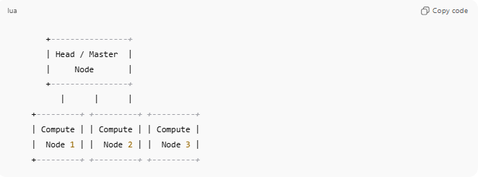
+----------------+
| Head / Master |
| Node |
+----------------+
| | |
+---------+ +---------+ +---------+
| Compute | | Compute | | Compute |
| Node 1 | | Node 2 | | Node 3 |
+---------+ +---------+ +---------+

How HPC Works
- A large problem is divided into smaller tasks
- Tasks are distributed to compute nodes
- Nodes process tasks simultaneously
- Results are combined into a final output

Key Characteristics
# Source: AI Source: Provided by: [Data Path: Persons Table -> ID Column: 1, Name_En Column: Motasem Essam] -> From: [ChatGPT] on [1/16/2026]
- Parallel processing
- High-speed interconnect (e.g., InfiniBand)
- Dedicated hardware (CPUs, GPUs, accelerators)
- Low-latency communication

Applications of HPC
# Source: AI Source: Provided by: [Data Path: Persons Table -> ID Column: 1, Name_En Column: Motasem Essam] -> From: [ChatGPT] on [1/16/2026]
- Weather forecasting and climate modeling
- Scientific simulations (physics, chemistry)
- Artificial intelligence and machine learning
- Bioinformatics and genome analysis
- Space research
- Financial risk modeling

Examples
# Source: AI Source: Provided by: [Data Path: Persons Table -> ID Column: 1, Name_En Column: Motasem Essam] -> From: [ChatGPT] on [1/16/2026]
- Supercomputers (Summit, Fugaku)
- University research clusters
- National research laboratories
- Engineering simulation centers

Advantages
# Source: AI Source: Provided by: [Data Path: Persons Table -> ID Column: 1, Name_En Column: Motasem Essam] -> From: [ChatGPT] on [1/16/2026]
- Extremely fast computation
- Handles massive data and complex models
- Scalable by adding more nodes

Disadvantages
# Source: AI Source: Provided by: [Data Path: Persons Table -> ID Column: 1, Name_En Column: Motasem Essam] -> From: [ChatGPT] on [1/16/2026]
- Very expensive to build and maintain
- Requires specialized programming (MPI, OpenMP)
- High power consumption

HPC vs Normal Cluster
# Source: AI Source: Provided by: [Data Path: Persons Table -> ID Column: 1, Name_En Column: Motasem Essam] -> From: [ChatGPT] on [1/16/2026]
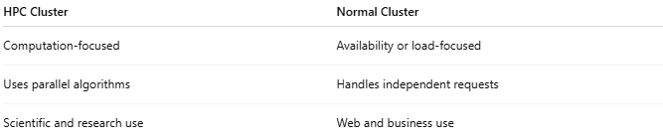
HPC Cluster | Normal Cluster
Computation-focused | Availability or load-focused
Uses parallel algorithms | Handles independent requests
Scientific and research use | Web and business use

Simple Analogy
# Source: AI Source: Provided by: [Data Path: Persons Table -> ID Column: 1, Name_En Column: Motasem Essam] -> From: [ChatGPT] on [1/16/2026]
- HPC: Hundreds of mathematicians solving one big problem together
- Normal cluster: Several workers handling separate tasks

